ITUE203: WEB DEVELOPMENT FRAMEWORKS 25CS106– Yana


Faculty of Technology and Engineering

Chandubhai S. Patel Institute of Technology (CSPIT) Department of Computer Science & Engineering

Laboratory manual
Academic Year | : | 2026-27 | Semester | : | 3rd

Practical - 10

PROBLEM STATEMENT :
Develop secure login and logout functionality using PHP sessions. Verify password using password_verify(), regenerate session ID after login, restrict dashboard access, implement role-based redirection, session timeout, and optional secure remember-me token.
OBJECTIVE:
To develop a secure login and logout system using PHP sessions with password verification, session ID regeneration, role-based redirection, dashboard access control, and session timeout management.

OUTPUT:
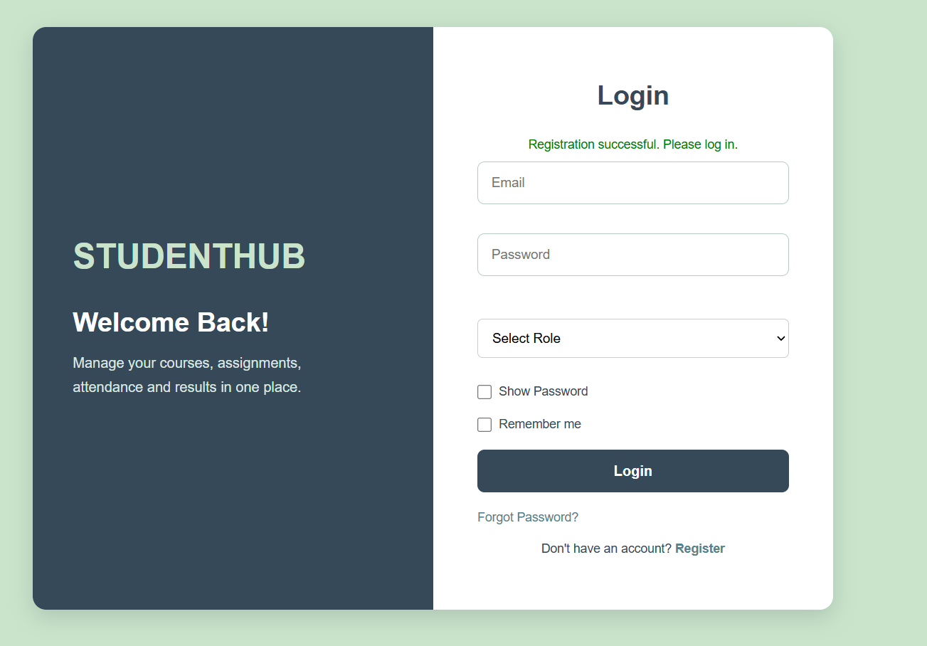
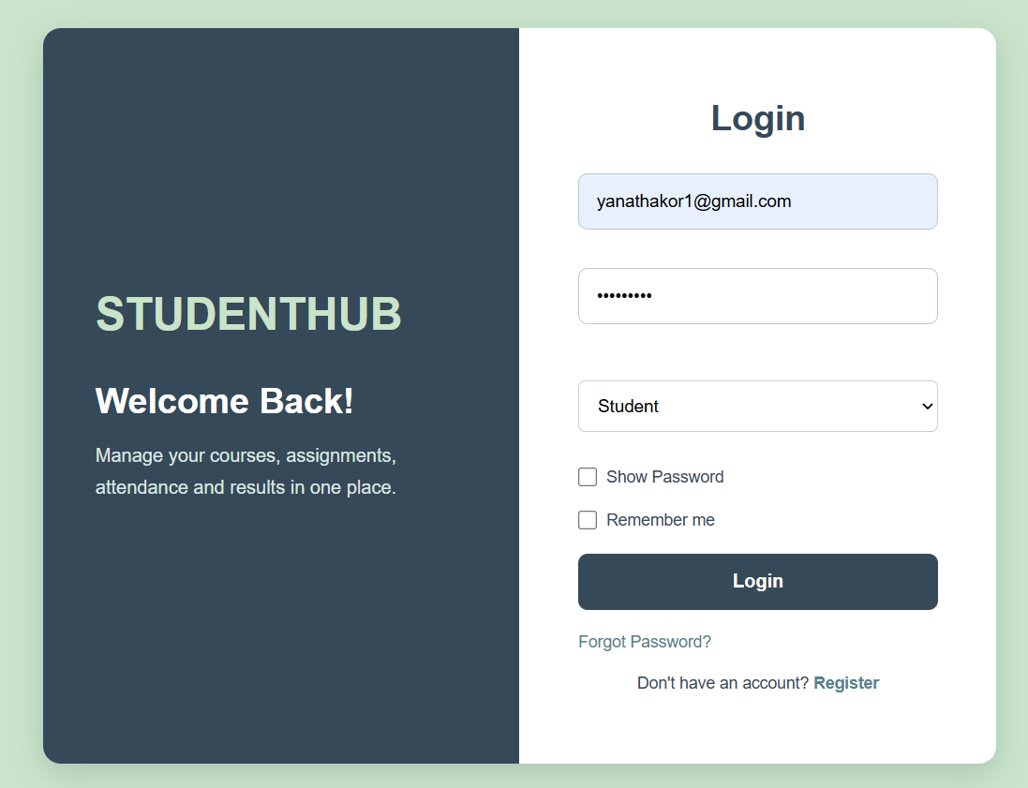
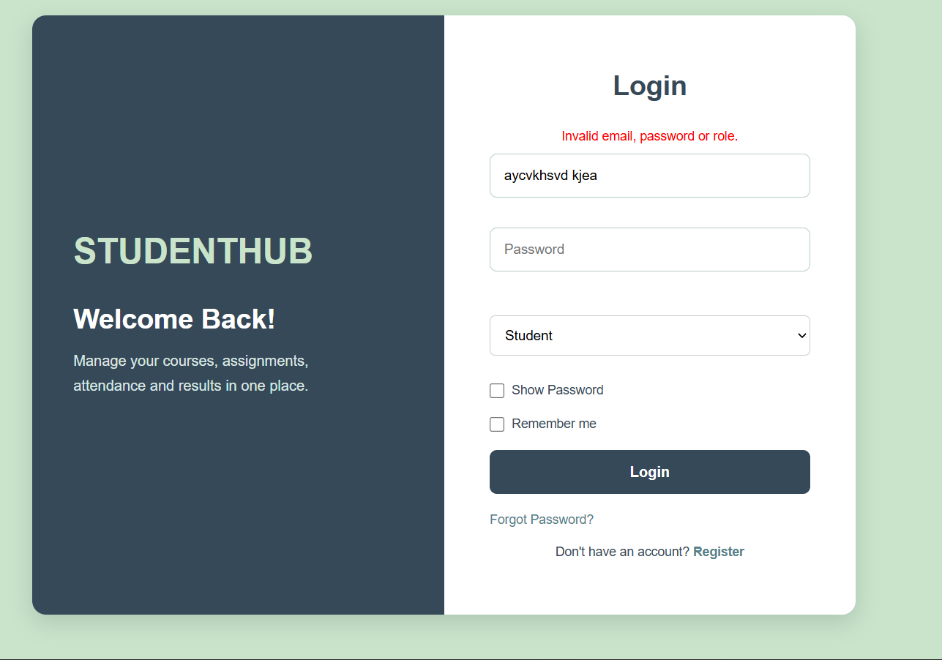

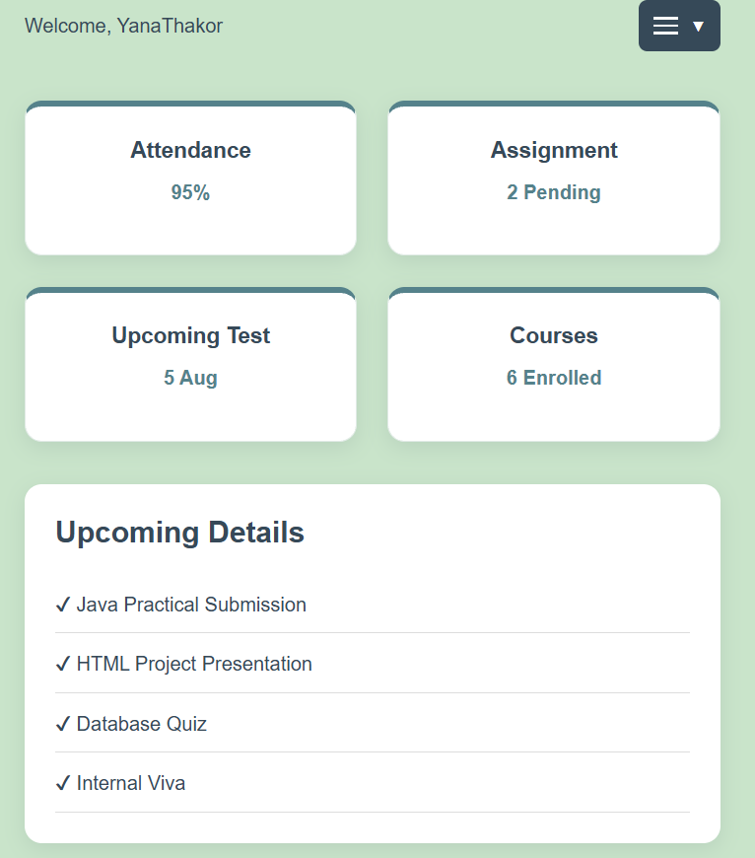
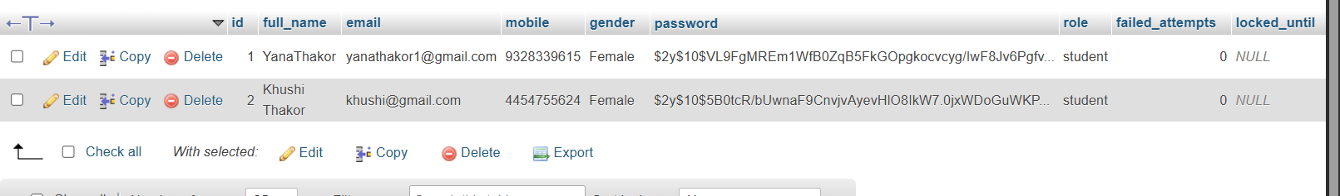

LEARNING OUTCOME:
- Implement secure user authentication using PHP sessions and password_verify().
- Regenerate session IDs after successful login to prevent session fixation attacks.
- Restrict dashboard access to authenticated users and implement role-based redirection.
- Implement secure logout and session timeout functionality.
- Understand the implementation of optional remember-me tokens for persistent and secure user authentication.

